## 

**DEPARTMENT OF COMPUTER SCIENCE & TECHNOLOGY**

**Subject Name:** Operating System  **Subject Code: CSH206B-T**

**Topic:** Introduction to Operating System

**Tutorial: 1**

**Objective: To gain familiarity with introductory concepts of OS**

**Course Outcome : CO1 : Learn architecture of OS**

**Bloom’s Taxonomy : BT1 : Knowledge**

Q1. Define Operating System?

An Operating System (OS) is an interface between a computer user and computer hardware. An operating system is a software which performs all the basic tasks like file management, memory management, process management, handling input and output, and controlling peripheral devices such as disk drives and printers.

Some popular Operating Systems include Linux Operating System, Windows Operating System, VMS, OS/400, AIX, z/OS, etc.

Q2. Mention the generation in terms of development of operating system for below mentioned terms:

1. Disks: 3rd

2. Batch systems: 2nd

3. Spooling: 3rd

4. Time-Sharing: 3rd

5. Multi-tasking/Multi-threading: 4th

Q3 Complete the below mentioned table based on the evolution of different operating systems

|  |  |  |  |
| --- | --- | --- | --- |
| Generation | Period | Computer Architecture | Problems and development of OSs |

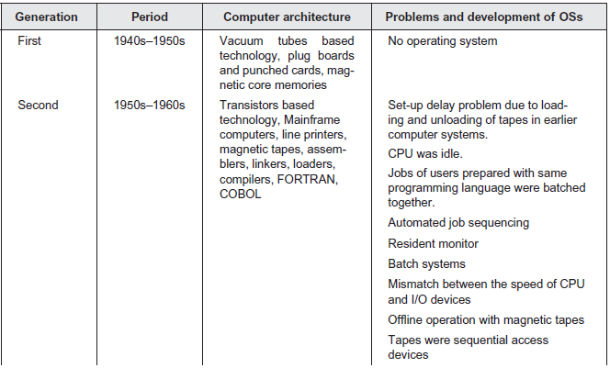

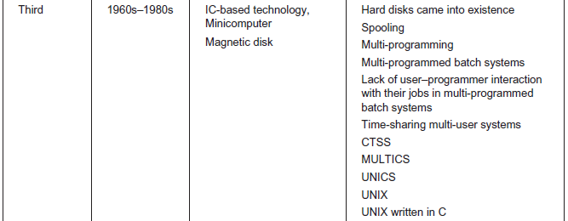

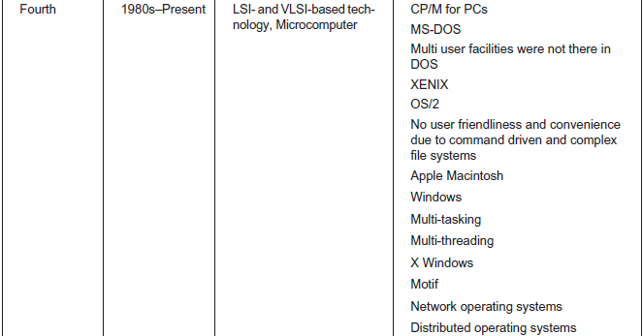

Q4. The major drawback of Multiprogrammed batch systems was the lack of user/programmer interaction with their jobs. How can you overcome this?

Through time sharing environment.

Q5. What is SPOOL? What is the benefit of spooling?

Spooling stands for "**Simultaneous Peripheral Operations Online**". So, in a Spooling, more than one I/O operations can be performed simultaneously i.e. at the time when the CPU is executing some process then more than one I/O operations can also de done at the same time.

#### Advantages of Spooling

* Since there is no interaction of I/O devices with CPU, so the CPU need not wait for the I/O operation to take place. The I/O operations take a large amount of time.
* The CPU is kept busy most of the time and hence it is not in the idle state which is good to have a situation.
* More than one I/O devices can work simultaneously.

Q6. What are the functions of operating system from user’s and system’s viewpoint?

**User View :**

The user’s view of the computer varies according to the interface being used. Most computer users sit in front of a PC, consisting of a monitor, keyboard, mouse, and system unit. Such a system is designed for one user to monopolize its resources. The goal is to maximize the work (or play) that the user is performing. In this case, the operating system is designed mostly for ease of use, with some attention paid to performance and none paid to resource utilization—how various hardware and software resources are shared. Performance is, of course, important to the user; but such systems are optimized for the single-user experience rather than the requirements of multiple users.

In other cases, a user sits at a terminal connected to a mainframe or a minicomputer. Other users are accessing the same computer through other terminals. These users share resources and may exchange information. The operating system in such cases is designed to maximize resource utilization — to assure that all available CPU time, memory, and I/O are used efficiently and that no individual user takes more than her fair share.

In still other cases, users sit at workstations connected to networks of other workstations and servers. These users have dedicated resources at their disposal, but they also share resources such as networking and servers, including file, compute, and print servers. Therefore, their operating system is designed to compromise between individual usability and resource utilization.

Recently, many varieties of mobile computers, such as smartphones and tablets, have come into fashion. Most mobile computers are standalone units for individual users. Quite often, they are connected to networks through cellular or other wireless technologies. Increasingly, these mobile devices are replacing desktop and laptop computers for people who are primarily interested in using computers for e-mail and web browsing. The user interface for mobile computers generally features a touch screen, where the user interacts with the system by pressing and swiping fingers across the screen rather than using a physical keyboard and mouse.

Some computers have little or no user view. For example, embedded computers in home devices and automobiles may have numeric keypads and may turn indicator lights on or off to show status, but they and their operating systems are designed primarily to run without user intervention.

**System View :**

From the computer’s point of view, the operating system is the program most intimately involved with the hardware. In this context, we can view an operating system as a resource allocator. A computer system has many resources that may be required to solve a problem: CPU time, memory space, file-storage space, I/O devices, and so on. The operating system acts as the manager of these resources. Facing numerous and possibly conflicting requests for resources, the operating system must decide how to allocate them to specific programs and users so that it can operate the computer system efficiently and fairly. As we have seen, resource allocation is especially important where many users access the same mainframe or minicomputer.

A slightly different view of an operating system emphasizes the need to control the various I/O devices and user programs. An operating system is a control program. A control program manages the execution of user programs to prevent errors and improper use of the computer. It is especially concerned with the operation and control of I/O devices.